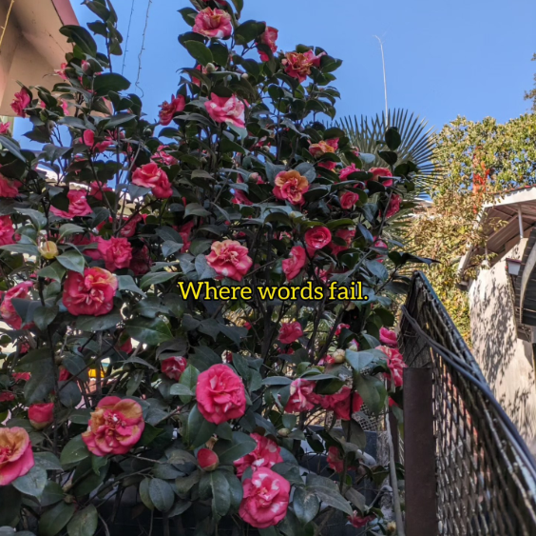
Where words fail.

1. Communicating with someone who has never heard a word, or seen a letter.

2. Telling someone they're beautiful when they cannot help but see only their "imperfections".

3. Telling someone you love them, when they've never experienced what it means.

4. Bringing someone back to a shared world when they've lost touch with reality- by choice, or without it.

5. Expressing what having a phobia feels like

6. Expressing you're feeling alone even when surrounded by people who seem to "know you well", when you're with them in the moment.

7. When you're sad, and your chest is sinking, and you have no clue why.

8. Explaining what a constant sense of imminent doom feels like.

9. Indian dads trying to tell their sons that they love them.

10. Consoling a friend who lost someone dear.

11. Telling someone "it's going to be okay" When they're convinced it doesn't get better.

12. Explaining why you would rather watch the world burn all at once than looking at those in power selectively choosing what deserves to be burnt.

13. Everywhere.

You'd be lying if you said you were ever able to verbally express yourself completely, ever.

Articulation is just an approximation, drawing shaky circles around a feeling, hoping people spot it.

It is a wonder how the world manages to function.

It does.

Because language developed around functional needs- and not experiential needs.

I wonder if we can ever truly communicate our experiential realities, I wonder if we ever truly can "understand" A person wholly- beyond a functional need.

